Scenario 1: Apply 1% Discount to Loan Interest Rates for Customers Above 60
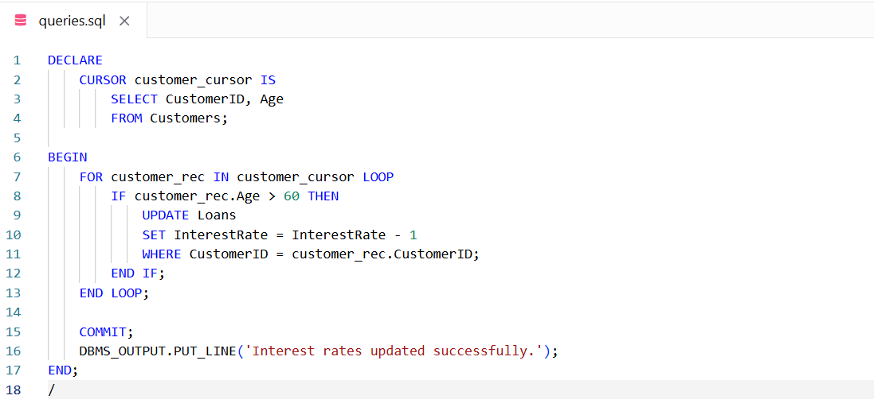

Scenario 2: Promote Customers to VIP Status
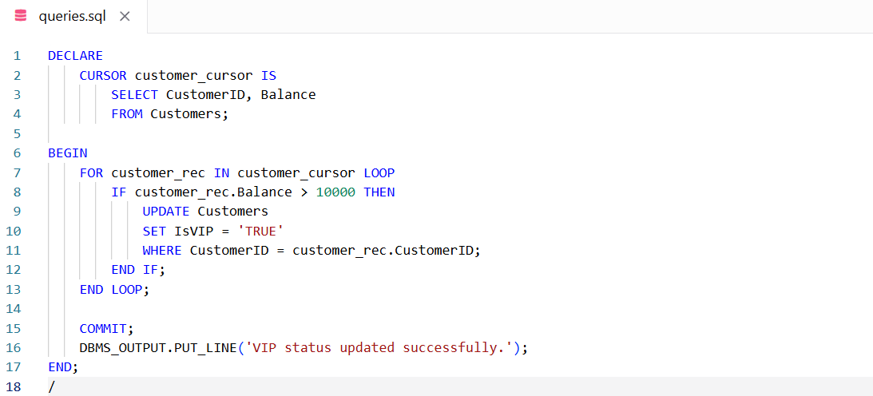

Scenario 3: Send Loan Due Reminders
